1. 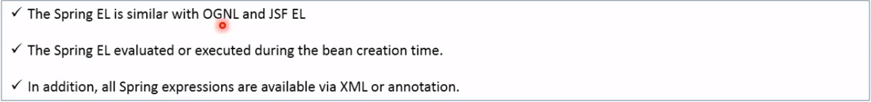
2. 
3. Injecting bean and its property value in other bean in xml.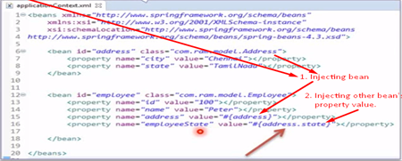
4. Injecting bean and its property value in other bean in annotation.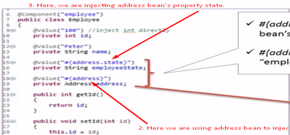
5. Injecting into bean’s property the value of other bean by calling the bean’s method.   
   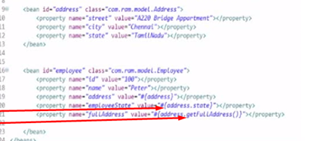
6. Injecting into bean’s property calling other’s bean method in annotation.   
   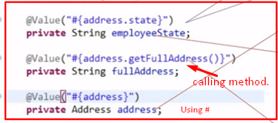
7. Conditional Checking in xml:   
   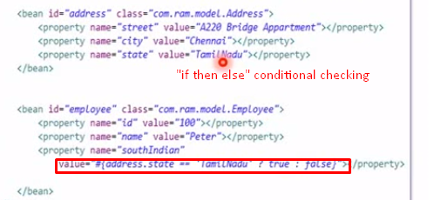
8. Conditional Checking in annotation:   
   
9. Rational Operators can be used which returns Boolean value 🡸 In xml file   
   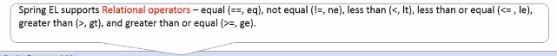
10. Rational Operators can be used which returns Boolean value 🡸 In Annotations.
11. Logical Operators in XML   
    
12. Mathematical Operators in XML  
    
13. Mathematical Operators in Annotations. 
14. Accessing Bean’s list elements in xml:   
    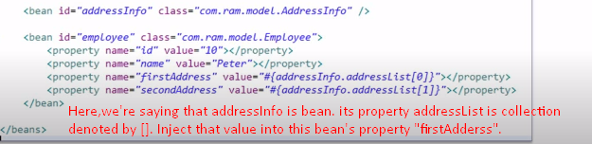
15. Accessing Bean’s List elements in Annotation:   
    
16. Accessing Bean’s map’s value in XML:   
    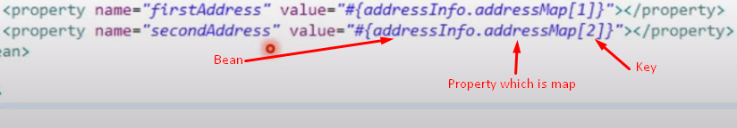
17. Accessing Bean’s map’s value in Annotation: 
18. **Regular expression in Spring Expression Language in XML**: 
19. **Regular expression in Spring Expression Language in Annotation.** 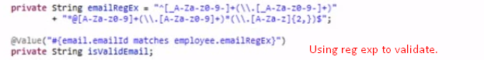
20. **Accessing static members of a bean in xml**:  
    
21. **Accessing static members of a bean in Annotation:**